Telemedicine Expands Access to Rural, Low-Income, Isolated Communities
Brandon May
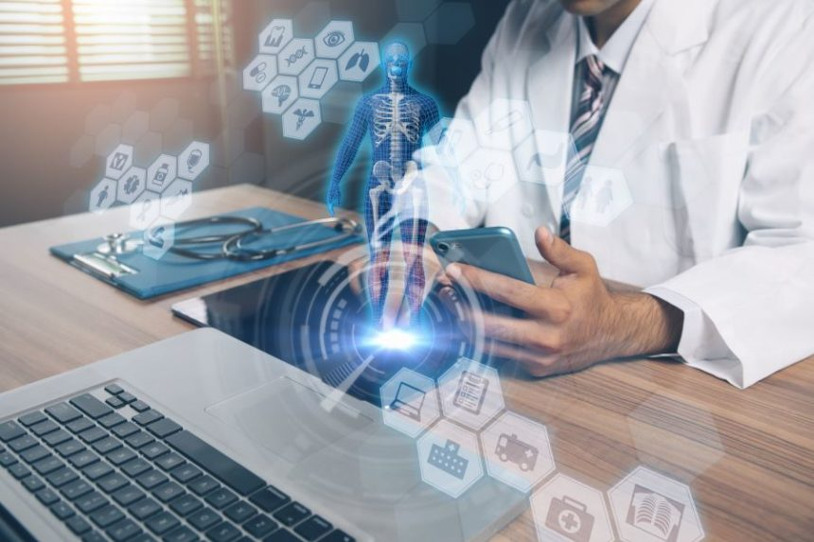
Improvements in digital technologies have enabled faster connection and communication between patients and providers.
Innovations in digital health and medicine applications are contributing to expanding medical care, particularly among individuals in rural, low-income, or isolated environments, as reported by researchers in the Lancet.
Economic disparities and shortages of healthcare professionals worldwide have been implicated as key contributors to inadequate global healthcare access, particularly among individuals living in rural, low-income areas.
Despite these disadvantages, improvements in digital technologies have enabled faster connection and communication between patients and providers. Digital medicine has become a more viable option for low-income and rural-residing individuals across the world, as 95% of the world’s population now has cellular coverage and Internet access.
Using telehealth, or digital medicine, providers can now diagnose some acute conditions, which may facilitate faster care and improved outcomes among certain population subsets. In addition, mobile phone-based video microscopy is now being used to identify some parasitic infections.
Ultrasound via smartphone device may also help remote providers evaluate, interpret, and diagnose conditions related to the heart, lungs, and abdominal regions. Some handheld ultrasound applications may help reduce the risk for life-threatening pregnancy complications, thereby potentially reducing worldwide maternal mortality rates.
Diabetes and hypertension, common conditions that affect a substantial proportion of the western population, may also be managed more effectively with digital medicine. Elderly individuals who live alone, for example, may benefit from digital medicine applications by having a provider with whom they can speak instantly about medications and symptoms.

Related Articles
- Standard Care vs Telemedicine for Diabetic Foot Ulcer Follow-up Care
- Survey Suggests Telemedicine Improves Access to Care
- Understanding Legal Limits of Telemedicine
Also, digital medicine holds great utility in the mental health field, helping to reach patients who may fear seeking treatment externally.
Digital medicine applications may ultimately create “systems of care built around improved communications, bringing care closer to, if not directly to, the individual, and bolstering self-management.”

Reference
Steinhubl SR, Kim K, Ajayi T, Topol EJ. Virtual care for improved global health. Lancet. 2018;391(10119):419.

