T1D Risk Increased Following Influenza A H1N1 Diagnosis in Children
Nicole Clemons
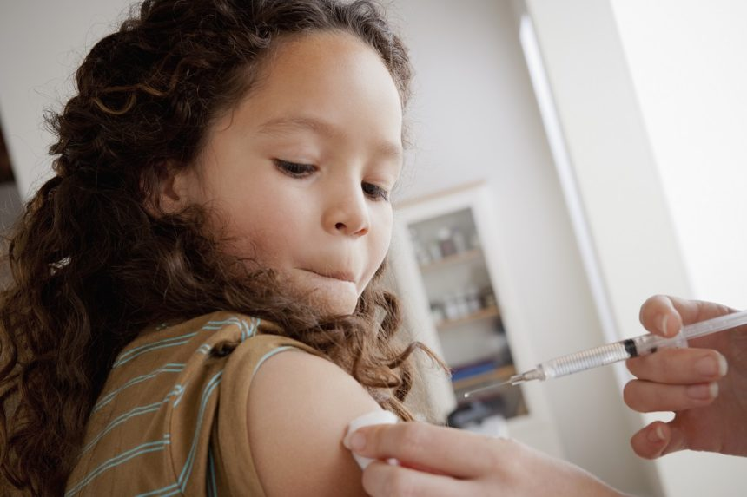
Study participants younger than 30 years were tracked from 2009 to 2014.
The 2009 pandemic influenza A H1N1 outbreak has been linked to an increased risk for new-onset type 1 diabetes (T1D) in children under the age of 15, according to a study presented at the 53rd European Association for the Study of Diabetes (EASD) Annual Meeting, held September 11-15 in Lisbon, Portugal.
Researchers at the Norwegian Institute of Public Health conducted a nationwide study to test whether a pandemic influenza diagnosis was associated with an increased risk for T1D. Using data from the Norwegian Patient Register, the study tracked participants under the age of 30 years from October 2009 to June 2014.
Defining pandemic influenza as a clinical influenza of influenza-like illness (ILI), the researchers identified 2297 participants diagnosed with T1D after the pandemic. Participants who registered with an ILI during the pandemic had an adjusted hazard ratio (aHR) for T1D of 1.18 (95% CI, 0.96-1.45). Using an age restriction of less than 15 years, aHR for T1D was significantly higher (1.34, 95% CI, 1.06-1.68).
The researchers also found that laboratory-confirmed infection with influenza A H1N1or hospitalization with an influenza diagnosis were both associated with a significant 2-fold higher risk for T1D, compared with those diagnosed with ILI in the pandemic season.

Reference
Ruiz PLD, Tapia, G, Bakken IJ, Håberg SE, Gulseth HL, Stene LC. Pandemic influenza diagnosis and subsequent risk of type 1 diabetes. Presented at: 53rd European Association for the Study of Diabetes Annual Meeting; September 11-15, 2017; Lisbon, Portugal. Abstract 363.

