Salzburg Consensus Criteria May Improve EEG Diagnostic Accuracy in Nonconvulsive Status Epilepticus
Brandon MayShare by Email
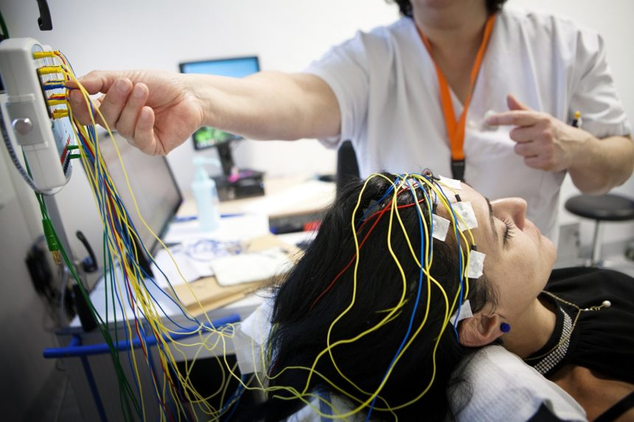An examiner trained in SCC diagnosed patients with NCSE or possible NCSE according to the SCC definition and compared these diagnoses with the initial diagnosis made by an expert EEG examiner.
The Salzburg Consensus Criteria (SCC), a potential diagnostic tool for nonconvulsive status epilepticus (NCSE), yielded similar diagnostic results by an inexperienced electroencephalogram (EEG) reader compared with an experienced EEG reader not using the SCC, according to study results in the Journal of Clinical Neurophysiology.
The first EEG data of patients who were admitted to a hospital in Denmark with suspected NCSE (n=284) were retrospectively re-analyzed in the study. To validate the diagnostic criteria, an examiner trained in SCC diagnosed patients with NCSE or possible NCSE according to the SCC definition, and these diagnoses were compared with the initial diagnosis made by an expert EEG examiner. The researchers also examined the clinical outcome in patients who were not diagnosed using SCC, or false-negatives.
A similar number of patients diagnosed with nonconvulsive status epilepticus or possible NCSE was observed in the inexperienced reader using the SCC and the experienced reader not using the SCC (40 vs 47, respectively). False-negatives, false-positives, true-positives, and true-negatives were recorded in 8 patients, 1 patient, 39 patients, and 236 patients, respectively. The researchers found high concordance between SCC and the reference standard (k=0.88; 95% CI, 0.80-0.96). Anoxic encephalopathy was recorded in four of the eight false-negatives, whereas the remaining patients had a history of epilepsy and subsequently returned to pre-ictal function.
Limitations of the study included the small sample size and the reliance on only one investigator who rated the EEGs.
“It is reassuring that most patients with a false-negative diagnosis according to the SCC were either patients with a known epilepsy, who returned to their preictal function, or patients with a post-anoxic brain damage who had a fatal outcome,” the researchers concluded. “This indicates that the original diagnosis reflected a postictal or interictal condition in patients with epilepsy and brain dysfunction in post-anoxic patients rather than status epilepticus.”
Reference
Krogstad MH, Høgenhaven H, Beier CP, Krøigård T. Nonconvulsive status epilepticus: validating the Salzburg criteria against an expert EEG examiner [published online December 21, 2018]. J Clin Neurophysiol. doi:10.1097/WNP.0000000000000556

