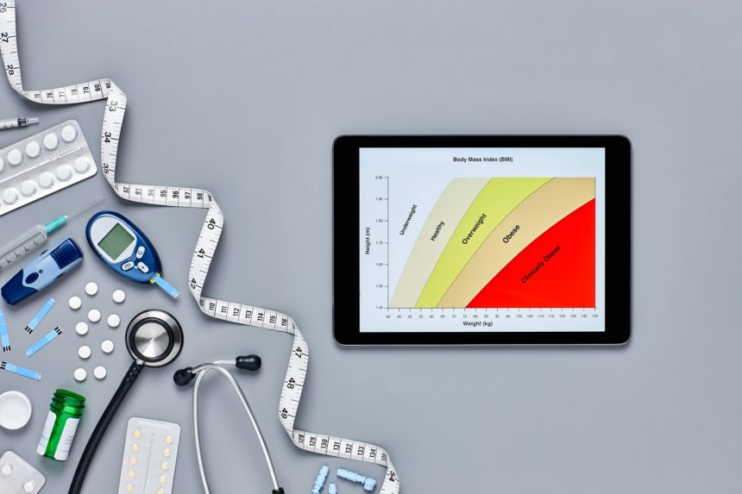
BMI Change During Male Puberty Associated With Risk for Type 2 Diabetes
Normalizing BMI during puberty may reduce risk for type 2 diabetes in men.
According to study results published in The Journal of Clinical Endocrinology & Metabolism, increased body mass index (BMI) during puberty might worsen the risk for adult type 2 diabetes (T2D) in men.To determine how changes in BMI during male puberty affect the risk of developing T2D, researchers assessed the outcomes of 36,176 men registered with the BMI Epidemiology Study Gothenburg in Sweden. The BMI of each participant was calculated from weight and height measurements taken at age 8 and 20 and the cohort was followed from age 30 until T2D diagnosis, migration, death, or study end date (average follow-up, 28.3 years).
In total, 1777 participants were diagnosed with T2D before the end of follow-up with a median age of 55.7 at diagnosis. The researchers discovered that high childhood BMI was nonlinearly associated with an elevated risk for T2D. This risk was strongest in participants who were overweight during childhood compared with normal-weight children (hazard ratio [HR], 2.09).
Men who normalized their weight during puberty showed no significant increase in the risk for T2D; the HR for developing T2D at age ≤55.7 was 1.28 and 1.35 for men who were age >55.7 in this population. However, compared with men who were never overweight, the risk for T2D was significantly higher in men who became overweight during puberty (HR, 4.67 at age ≤55.7; HR, 2.85 at age >55.7) and men who were overweight in childhood/young adulthood (HR, 4.82 at age ≤55.7; HR, 3.04 at age >55.7).
Reference
Ohlsson C, Bygdell M, Nethander M, Rosengren A, Kindblom JM. BMI change during puberty is an important determinant of adult type 2 diabetes risk in men [published online December 4, 2018]. J Clin Endocrinol Metab. doi:10.1210/jc.2018-01339

