Assessing Negative Attitudes Toward Weight Loss Surgery in US
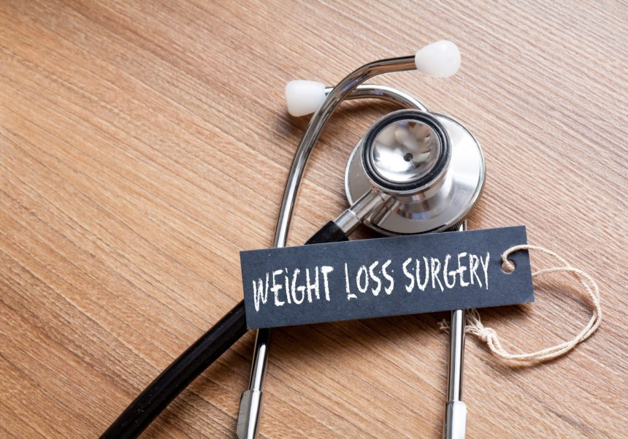
A large proportion of the U.S. population seems to have negative attitudes toward weight-loss surgery.
HealthDay News — A large proportion of the U.S. population seems to have negative attitudes toward weight-loss surgery, according to a research letter published online Dec. 12 in JAMA Surgery.Patrick Dolan, M.D., from Weill Cornell Medicine in New York City, and colleagues conducted a cross-sectional survey to examine attitudes toward weight-loss surgery in the U.S. population. Three questions were developed as part of the Cornell National Social Survey, and 1,000 persons contacted complied with interviews. The final cohort included 948 participants (mean age, 48 years) with complete data.
The researchers found that 49.4 and 39.1 percent of respondents thought that most people had weight-loss surgery for cosmetic reasons and that weight-loss surgery represented choosing the “easy way out.”
Women were more likely to think that weight-loss surgery was performed for health reasons, less likely to consider it the easy way out, and less likely to think it should not be covered by health insurance (odds ratios, 1.34, 0.54, and 0.48, respectively). Non-Hispanic black participants were more likely to consider surgery an easy way out (odds ratio, 1.61).
“Further research is needed with respect to normalizing weight-loss surgery as a reasonable option for managing obesity,” the authors write. “There is no simple way to fix this problem, and it may take years of public and physician education regarding the health benefits of weight-loss surgery to improve its perception and increase its utilization.”

Related Articles
- Reduced Fertility in Obese Women May Be Related to Dysfunctional Insulin Pathway
- Hypertensive Disorders in Pregnancy, Postpartum BMI Linked to T2D Risk
- Parental Perception of Child Weight Status Predicted by Child BMI z Scores

